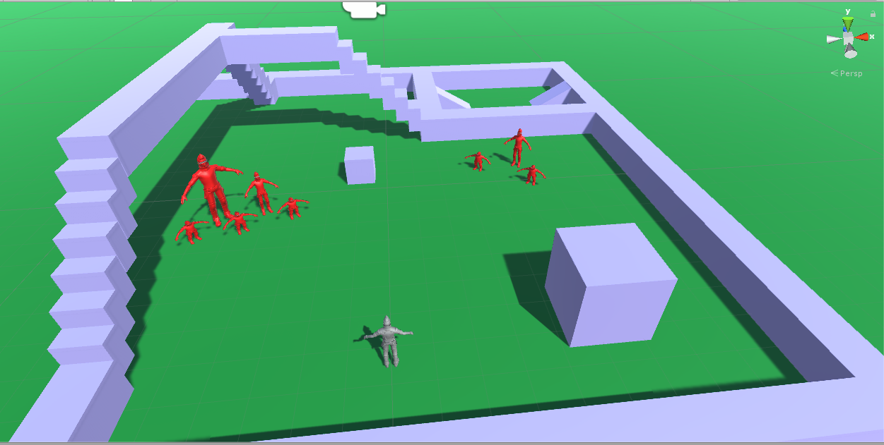

1 Melee Attack – Run up to enemy and attack

2 Ranged Attack – Run within attack range and attack enemy

3 Spell Attack – Run within attack range and cast spell

4 Run past enemy – run to desired point even enemy attacks on way to point

5 Attack specific enemy – Run up to enemy even if he is behind other enemies and attack just him

Controller?

1 Attack button

2 Stand and aim and shoot (with aim assist)